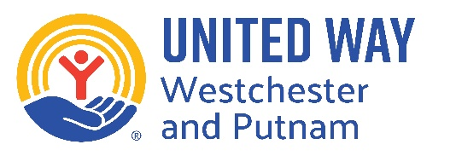

UNITED WAY OF WESTCHESTER AND PUTNAM
COMMUNITY IMPACT GRANT APPLICATION

The United Way of Westchester and Putnam Community Impact Fund supports local nonprofits serving the needs of the under-resourced or ALICE (Asset Limited, Income Constrained, Employed; those who are employed but are living paycheck-to-paycheck) populations in Westchester or Putnam Counties.

United Way offers grants between $5,000 and $10,000.

The funding can be used in two ways: 1) to support programs in the areas of education, financial stability, or health that benefit under-resourced or ALICE populations in Westchester or Putnam counties, or 2) to support operational expenses of local nonprofits in Westchester or Putnam County whose mission relates to improving the education, financial stability, or health of under-resourced or ALICE populations.

The submission deadline, which includes the application and the required attachments, is 5 p.m. on May 22, 2026.

Applications can be submitted online at uwwp.org/community-impact-grant or via email at jcabrera@uwwp.org.

GENERAL INFORMATION

Agency Name:
Address:
Phone Number:
Chief Professional Officer Name and Title:
Chief Professional Officer Email Address:
Application Completed By:
Email Address for person completing application:

ATTACHMENTS
Please submit the most recent copy of each of the following:
- 501(c)(3) Tax Exempt Status Certificate
- Most recent 990 Tax filing or Audited Financial Statement
- Board of Directors Roster
- Organizational Budget
- Budget for specific program (if applicable)

INFORMATION

- Describe the mission of your organization.

- Describe the program/service for which the grant will be used. If for General Operating purposes, please explain why you are seeking that type of support.
- What population(s) will be served by this grant? Please be as specific as possible and list the demographic groups you intend to serve.
- What are the communities in which you serve the population(s) listed above? (Please note, you can only serve Westchester and/or Putnam residents with these funds.)
- Describe how the program/service will address the needs of the under-resourced or ALICE populations (those who are employed but are living paycheck-to-paycheck). Examples of services considered but not limited to: providing food, clothing, housing, or other essential needs to families. If seeking General Operating support, please explain how your organization serves these populations.

- What is the intended impact or long-term goal of this project/service?
- How visible is this program/service in the community? How will you promote/publicize United Way’s support of it?
$
- Amount requested from United Way of Westchester and Putnam:
$
- Total budget of activity for which funds are being requested:

The United Way of Westchester and Putnam has a Board approved policy demonstrating its commitment to funding organizations that provide services and offer employment and volunteer opportunities to all, without discriminating on the basis of age, gender, race, religion, sexual orientation, ethnicity, national origin or disability. This policy supports agencies that offer non-discriminatory programs to all. By signing this application, your organization certifies its understanding of and compliance with this policy.

I/We certify that the information provided in this application is true and correct to the best of my knowledge and belief.

_________________________________________________________
Chief Professional Officer Signature Date

